ITA0601-ML
LAB PROGRAM
B HARISH BALAJI
192424386

EXP.7:
CODE:
# 7. Logistic Regression - Student Placement Prediction

import pandas as pd
from sklearn.model_selection import train_test_split
from sklearn.linear_model import LogisticRegression
from sklearn.metrics import accuracy_score, classification_report

# Create dataset
data = {
"CGPA": [9.2, 8.8, 8.5, 7.2, 6.8,
9.0, 7.5, 8.6, 6.5, 8.9],

"Aptitude": [90, 85, 80, 72, 68,
92, 75, 84, 60, 88],

"Communication": [88, 82, 79, 70, 65,
90, 74, 81, 58, 86],

"Placement": [1, 1, 1, 0, 0,
1, 0, 1, 0, 1]
}

df = pd.DataFrame(data)

print("Dataset:")
print(df)

# Input features
X = df[["CGPA", "Aptitude", "Communication"]]

# Target variable
y = df["Placement"]

# Split dataset
X_train, X_test, y_train, y_test = train_test_split(
X, y,
test_size=0.3,
random_state=42
)

# Create Logistic Regression model
model = LogisticRegression()

# Train the model
model.fit(X_train, y_train)

# Predict test data
y_pred = model.predict(X_test)

# Display results
print("\nActual Values:")
print(y_test.values)

print("\nPredicted Values:")
print(y_pred)

# Accuracy
accuracy = accuracy_score(y_test, y_pred)

print("\nAccuracy:", accuracy)

# Classification report
print("\nClassification Report:")
print(classification_report(y_test, y_pred, zero_division=0))

# Predict a new student
new_student = [[8.7, 86, 84]]

prediction = model.predict(new_student)

if prediction[0] == 1:
print("\nNew Student Prediction: Placed")
else:
print("\nNew Student Prediction: Not Placed")

OUTPUT:
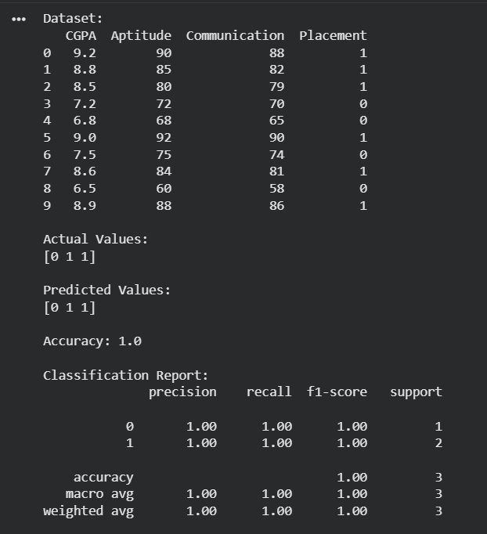

EXP8:
CODE:
# 8. Linear Regression - House Price Prediction

import pandas as pd
from sklearn.linear_model import LinearRegression

# Create dataset
data = {
"Plot_Area": [1200, 1500, 1800, 2000, 2200,
2400, 2600, 2800, 3000],

"Builtup_Area": [1000, 1300, 1500, 1700, 1900,
2100, 2300, 2500, 2700],

"Bathrooms": [2, 2, 3, 3, 4,
4, 5, 5, 6],

"Price": [60, 75, 95, 110, 128,
150, 174, 200, 228]
}

df = pd.DataFrame(data)

print("Dataset:")
print(df)

# Input features
X = df[["Plot_Area", "Builtup_Area", "Bathrooms"]]

# Target variable
y = df["Price"]

# Create Linear Regression model
model = LinearRegression()

# Train the model
model.fit(X, y)

# Display model coefficients
print("\nCoefficients:")
print(model.coef_)

print("\nIntercept:")
print(model.intercept_)

# New house sample
new_house = [[2300, 2000, 4]]

# Predict house price
prediction = model.predict(new_house)

print("\nNew House Details:")
print("Plot Area :", 2300, "sq.ft")
print("Built-up Area :", 2000, "sq.ft")
print("Bathrooms :", 4)

print("\nPredicted House Price:",
prediction[0], "Lakhs")

OUTPUT:
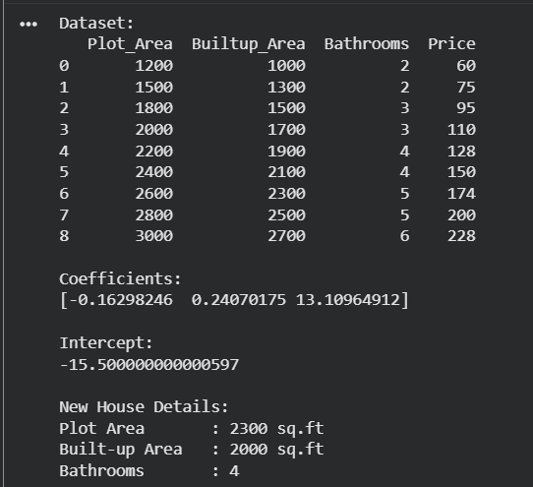

EXP9:
CODE:
# 9. Compare Linear Regression and Polynomial Regression

import numpy as np
import matplotlib.pyplot as plt

from sklearn.linear_model import LinearRegression
from sklearn.preprocessing import PolynomialFeatures
from sklearn.metrics import mean_squared_error, r2_score

# Dataset from the given question
X = np.array([
800, 1000, 1200, 1400, 1600,
1800, 2000, 2200, 2400, 2600
]).reshape(-1, 1)

y = np.array([
32, 40, 52, 68, 88,
112, 140, 172, 208, 248
])

# -------------------------------
# Linear Regression
# -------------------------------

linear_model = LinearRegression()
linear_model.fit(X, y)

linear_prediction = linear_model.predict(X)

# -------------------------------
# Polynomial Regression
# -------------------------------

poly = PolynomialFeatures(degree=2)

X_poly = poly.fit_transform(X)

poly_model = LinearRegression()
poly_model.fit(X_poly, y)

poly_prediction = poly_model.predict(X_poly)

# -------------------------------
# Compare Models
# -------------------------------

linear_mse = mean_squared_error(y, linear_prediction)
poly_mse = mean_squared_error(y, poly_prediction)

linear_r2 = r2_score(y, linear_prediction)
poly_r2 = r2_score(y, poly_prediction)

print("LINEAR REGRESSION")
print("-------------------------")
print("MSE :", linear_mse)
print("R2 Score :", linear_r2)

print("\nPOLYNOMIAL REGRESSION")
print("-------------------------")
print("MSE :", poly_mse)
print("R2 Score :", poly_r2)

# -------------------------------
# Predict New Sample
# -------------------------------

new_sample = np.array([[1700]])

linear_result = linear_model.predict(new_sample)

new_sample_poly = poly.transform(new_sample)
poly_result = poly_model.predict(new_sample_poly)

print("\nPrediction for House Size = 1700 sq.ft")
print("----------------------------------------")

print("Linear Regression Prediction :",
linear_result[0], "Lakhs")

print("Polynomial Regression Prediction :",
poly_result[0], "Lakhs")

# -------------------------------
# Plot Comparison
# -------------------------------

X_curve = np.linspace(800, 2600, 100).reshape(-1, 1)

linear_curve = linear_model.predict(X_curve)

poly_curve = poly_model.predict(
poly.transform(X_curve)
)

plt.scatter(X, y, label="Actual Data")

plt.plot(
X_curve,
linear_curve,
label="Linear Regression"
)

plt.plot(
X_curve,
poly_curve,
label="Polynomial Regression"
)

plt.xlabel("House Size (sq.ft)")
plt.ylabel("House Price (₹ Lakhs)")
plt.title("Linear vs Polynomial Regression")

plt.legend()
plt.show()

OUTPUT:
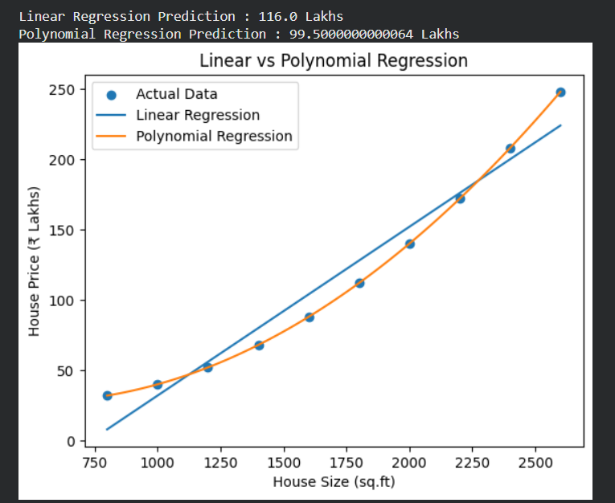

EXP10:
CODE:
# 10. Expectation-Maximization Algorithm

import numpy as np
from sklearn.mixture import GaussianMixture

# Create the dataset
X = np.array([
[2, 65],
[3, 70],
[4, 75],
[5, 80],
[6, 85],
[7, 88],
[8, 90],
[9, 93],
[10, 95],
[11, 98]
])

# Create Gaussian Mixture Model
# GaussianMixture uses the EM algorithm
model = GaussianMixture(
n_components=2,
random_state=42
)

# Train the model
model.fit(X)

# Predict cluster labels
labels = model.predict(X)

# Display results
print("Student Performance Data:")
print(X)
print("\nCluster Labels:")
print(labels)

print("\nCluster Means:")
print(model.means_)

print("\nCluster Weights:")
print(model.weights_)
new_sample = np.array([[7, 89]])
new_cluster = model.predict(new_sample)
print("\nNew Sample:")
print("Study Hours :", 7)
print("Attendance (%) :", 89)

print("\nPredicted Cluster:",
new_cluster[0])

OUTPUT:
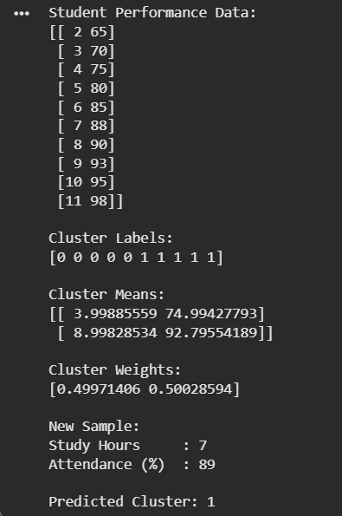
EXP11:

CODE:
# 11. Credit Score Classification
# Using Decision Tree Classifier

import pandas as pd
from sklearn.tree import DecisionTreeClassifier
from sklearn.model_selection import train_test_split
from sklearn.preprocessing import LabelEncoder
from sklearn.metrics import accuracy_score, classification_report

# Create dataset
data = {
"Salary": [5, 6, 7, 8, 9, 10, 11, 12, 13, 14],
"CIBIL_Score": [600, 620, 650, 680, 700,
720, 750, 770, 790, 830],
"Existing_EMIs": [5, 5, 4, 4, 3,
3, 2, 2, 2, 1],
"Credit_Score": [
"Poor",
"Poor",
"Average",
"Average",
"Average",
"Good",
"Good",
"Good",
"Excellent",
"Excellent"
]
}

df = pd.DataFrame(data)

print("Dataset:")
print(df)

# Input features
X = df[["Salary", "CIBIL_Score", "Existing_EMIs"]]

# Target variable
y = df["Credit_Score"]

# Encode target labels
encoder = LabelEncoder()
y_encoded = encoder.fit_transform(y)

# Split dataset
X_train, X_test, y_train, y_test = train_test_split(
X,
y_encoded,
test_size=0.3,
random_state=42
)

# Create Decision Tree model
model = DecisionTreeClassifier(
criterion="entropy",
random_state=42
)

# Train model
model.fit(X_train, y_train)

# Prediction
y_pred = model.predict(X_test)

# Display results
print("\nActual Values:")
print(encoder.inverse_transform(y_test))

print("\nPredicted Values:")
print(encoder.inverse_transform(y_pred))

# Accuracy
accuracy = accuracy_score(y_test, y_pred)

print("\nAccuracy:", accuracy)

# Classification report
print("\nClassification Report:")
print(
classification_report(
y_test,
y_pred,
target_names=encoder.classes_,
zero_division=0
)
)

# New customer
new_customer = [[11, 790, 2]]

prediction = model.predict(new_customer)

print("\nNew Customer:")
print("Salary : 11 Lakhs")
print("CIBIL Score : 790")
print("Existing EMIs : 2")

print("\nPredicted Credit Score:",
encoder.inverse_transform(prediction)[0])V

OUTPUT:
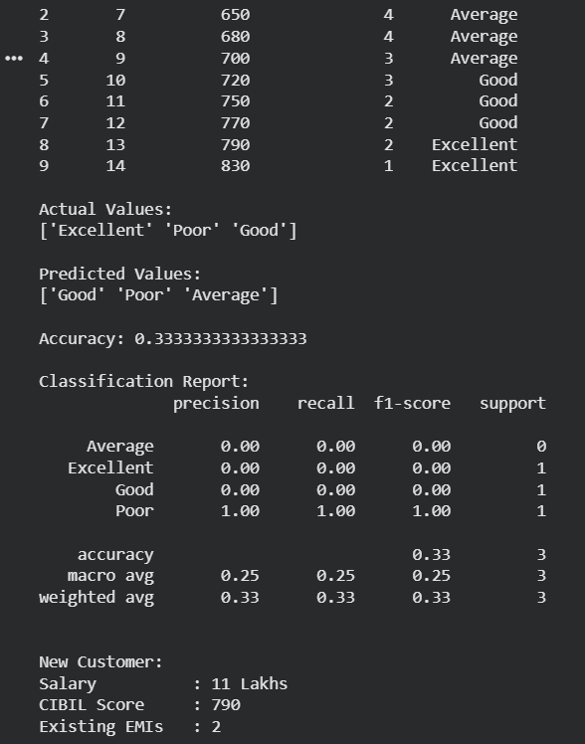

EXP12:
# 12. Classification using KNN
# Fruit Classification Dataset

import pandas as pd
from sklearn.model_selection import train_test_split
from sklearn.neighbors import KNeighborsClassifier
from sklearn.preprocessing import LabelEncoder
from sklearn.metrics import accuracy_score, classification_report

# Create dataset
data = {
"Weight": [150, 160, 145, 120, 125,
130, 155, 118, 148, 122],

"Diameter": [7.5, 7.8, 7.3, 5.5, 5.8,
6.0, 7.6, 5.4, 7.4, 5.7],

"Sweetness": [90, 88, 91, 70, 72,
74, 89, 69, 92, 71],

"Fruit": [
"Apple", "Apple", "Apple",
"Orange", "Orange", "Orange",
"Apple", "Orange", "Apple", "Orange"
]
}

df = pd.DataFrame(data)

print("Dataset:")
print(df)

# Input features
X = df[["Weight", "Diameter", "Sweetness"]]

# Target variable
y = df["Fruit"]

# Convert fruit names into numerical values
encoder = LabelEncoder()
y_encoded = encoder.fit_transform(y)

# Split dataset
X_train, X_test, y_train, y_test = train_test_split(
X,
y_encoded,
test_size=0.3,
random_state=42
)

# Create KNN model
knn = KNeighborsClassifier(n_neighbors=3)

# Train model
knn.fit(X_train, y_train)

# Predict test data
y_pred = knn.predict(X_test)

# Display actual and predicted values
print("\nActual Values:")
print(encoder.inverse_transform(y_test))

print("\nPredicted Values:")
print(encoder.inverse_transform(y_pred))

# Accuracy
accuracy = accuracy_score(y_test, y_pred)

print("\nAccuracy:", accuracy)

# Classification report
print("\nClassification Report:")
print(
classification_report(
y_test,
y_pred,
target_names=encoder.classes_,
zero_division=0
)
)

# Predict new sample
new_fruit = [[152, 7.5, 90]]

prediction = knn.predict(new_fruit)

print("\nNew Fruit:")
print("Weight : 152 g")
print("Diameter : 7.5 cm")
print("Sweetness : 90%")

print("\nPredicted Fruit:",
encoder.inverse_transform(prediction)[0])

OUTPUT:
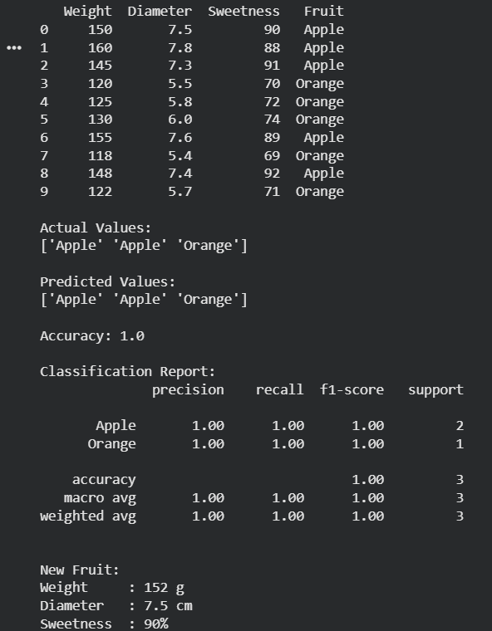

EXP13:
CODE:
# 13. Car Price Prediction
# Electric Car Price Prediction using Linear Regression

import pandas as pd
from sklearn.linear_model import LinearRegression

# Create dataset
data = {
"Battery_Capacity": [30, 35, 40, 45, 50,
55, 60, 65, 70, 75],

"Range": [250, 300, 350, 400, 450,
500, 550, 600, 650, 700],

"Charging_Time": [8, 8, 7, 7, 6,
6, 5, 5, 4, 4],

"Price": [10.5, 12.0, 14.0, 16.5, 18.5,
21.0, 24.0, 27.5, 31.0, 35.0]
}

df = pd.DataFrame(data)

# Display dataset
print("Electric Car Dataset:")
print(df)

# Input features
X = df[["Battery_Capacity", "Range", "Charging_Time"]]

# Target variable
y = df["Price"]

# Create Linear Regression model
model = LinearRegression()

# Train the model
model.fit(X, y)

# Display coefficients
print("\nModel Coefficients:")
print(model.coef_)

print("\nModel Intercept:")
print(model.intercept_)

# New car sample
new_car = [[52, 470, 6]]

# Predict car price
prediction = model.predict(new_car)

print("\nNew Car Details:")
print("Battery Capacity :", 52, "kWh")
print("Range :", 470, "km")
print("Charging Time :", 6, "hours")

print("\nPredicted Car Price:",
round(prediction[0], 2), "Lakhs")

OUTPUT:
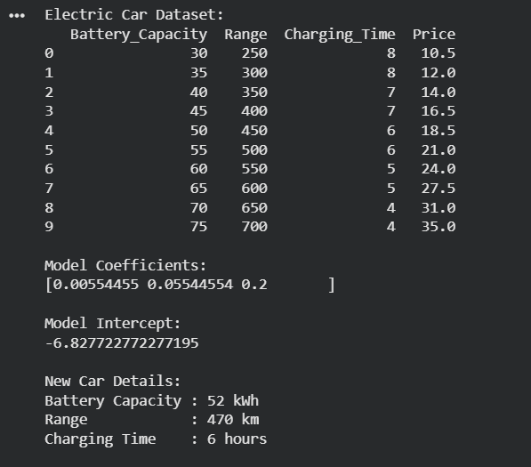

EXP14:
CODE:
# 14. House Price Prediction
# Using Linear Regression

import pandas as pd
from sklearn.linear_model import LinearRegression

# Create dataset
data = {
"Plot_Area": [
1200, 1400, 1600, 1800, 2000,
2200, 2400, 2600, 2800, 3000
],

"Builtup_Area": [
1000, 1200, 1400, 1600, 1700,
1900, 2100, 2300, 2500, 2700
],

"Bathrooms": [
2, 2, 3, 3, 3,
4, 4, 5, 6, 6
],

"Price": [
60, 72, 85, 105, 115,
128, 150, 174, 200, 228
]
}

# Create DataFrame
df = pd.DataFrame(data)

print("House Price Dataset:")
print(df)

# Input features
X = df[["Plot_Area", "Builtup_Area", "Bathrooms"]]

# Target variable
y = df["Price"]

# Create Linear Regression model
model = LinearRegression()

# Train the model
model.fit(X, y)

# Display model parameters
print("\nModel Coefficients:")
print(model.coef_)

print("\nModel Intercept:")
print(model.intercept_)

# New house sample
new_house = [[2300, 2000, 4]]

# Predict house price
prediction = model.predict(new_house)

print("\nNew House Details:")
print("Plot Area :", 2300, "sq.ft")
print("Built-up Area :", 2000, "sq.ft")
print("Bathrooms :", 4)

print("\nPredicted House Price:",
round(prediction[0], 2), "Lakhs")

OUTPUT:
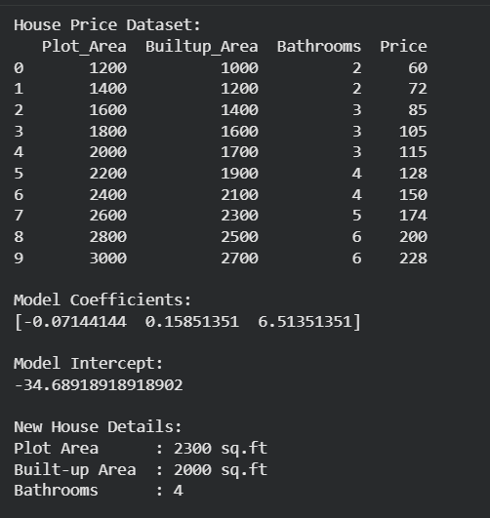

EXP15:

# 15. Classification using Naive Bayes
# Fruit Classification Dataset

import pandas as pd
from sklearn.model_selection import train_test_split
from sklearn.naive_bayes import GaussianNB
from sklearn.preprocessing import LabelEncoder
from sklearn.metrics import accuracy_score, classification_report

# Create dataset
data = {
"Weight": [150, 160, 145, 120, 125,
130, 155, 118, 148, 122],

"Diameter": [7.5, 7.8, 7.3, 5.5, 5.8,
6.0, 7.6, 5.4, 7.4, 5.7],

"Sweetness": [90, 88, 91, 70, 72,
74, 89, 69, 92, 71],

"Fruit": [
"Apple", "Apple", "Apple",
"Orange", "Orange", "Orange",
"Apple", "Orange", "Apple", "Orange"
]
}

# Create DataFrame
df = pd.DataFrame(data)

print("Dataset:")
print(df)

# Input features
X = df[["Weight", "Diameter", "Sweetness"]]

# Target variable
y = df["Fruit"]

# Convert class labels into numbers
encoder = LabelEncoder()
y_encoded = encoder.fit_transform(y)

# Split dataset
X_train, X_test, y_train, y_test = train_test_split(
X,
y_encoded,
test_size=0.3,
random_state=42
)

# Create Naive Bayes model
model = GaussianNB()

# Train the model
model.fit(X_train, y_train)

# Predict test data
y_pred = model.predict(X_test)

# Display actual and predicted values
print("\nActual Values:")
print(encoder.inverse_transform(y_test))

print("\nPredicted Values:")
print(encoder.inverse_transform(y_pred))

# Calculate accuracy
accuracy = accuracy_score(y_test, y_pred)

print("\nAccuracy:", accuracy)

# Classification report
print("\nClassification Report:")
print(
classification_report(
y_test,
y_pred,
target_names=encoder.classes_,
zero_division=0
)
)

# New sample
new_fruit = [[152, 7.5, 90]]

# Predict new sample
prediction = model.predict(new_fruit)

print("\nNew Fruit Details:")
print("Weight : 152 g")
print("Diameter : 7.5 cm")
print("Sweetness : 90%")

print("\nPredicted Fruit:",
encoder.inverse_transform(prediction)[0])

OUTPUT:

